Time stream queries

* AWS Rule to get data from MQTT to Timestream Db

SELECT * FROM 'arduino/ldr-servo'

* Queries to check the data from the Timestream Db

SELECT

time,

MAX(CASE WHEN measure_name = 'LDR1' THEN measure_value::double END) AS LDR1,

MAX(CASE WHEN measure_name = 'LDR2' THEN measure_value::double END) AS LDR2,

MAX(CASE WHEN measure_name = 'Voltage' THEN measure_value::double END) AS Voltage,

MAX(CASE WHEN measure_name = 'Humid' THEN measure_value::double END) AS Humid

FROM "SolarTrackingDB"."SensorDataTable"

GROUP BY time

ORDER BY time DESC

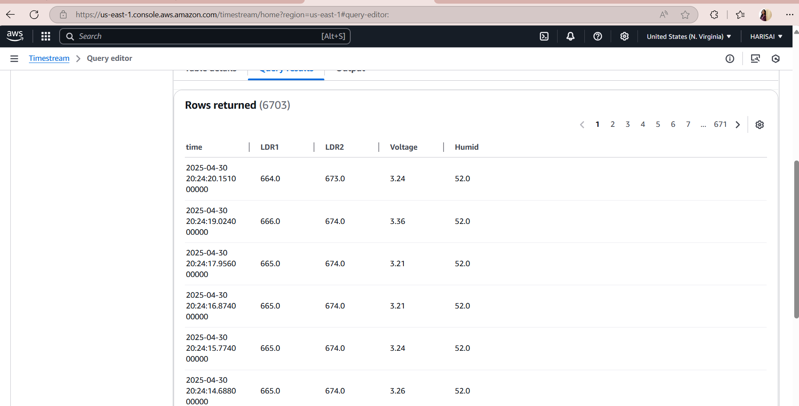

SELECT *

FROM "SolarTrackingDB"."SensorDataTable"

ORDER BY time DESC

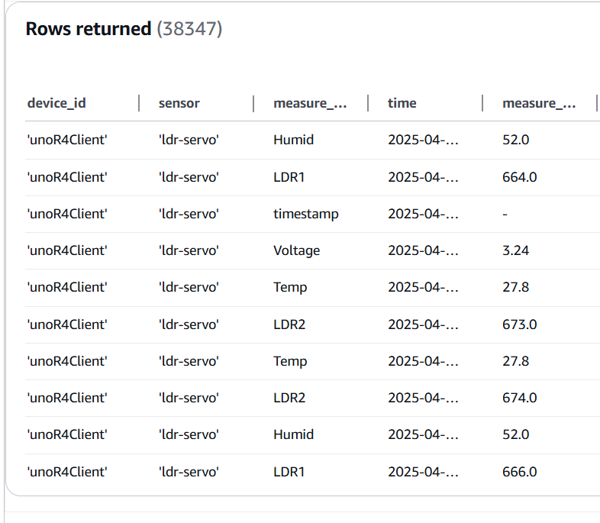

Query used for Grafana Visualization

WITH temp_data AS (

  SELECT time, measure_value::double AS temp_value

  FROM "SolarTrackingDB"."SensorDataTable"

  WHERE measure_name = 'Temp'

),

ldr_data AS (

  SELECT time, measure_value::double AS ldr1_value

  FROM "SolarTrackingDB"."SensorDataTable"

  WHERE measure_name = 'LDR1'

)

SELECT

  ldr_data.time,

  ldr1_value,

  temp_value

FROM ldr_data

JOIN temp_data ON ldr_data.time = temp_data.time

ORDER BY ldr_data.time ASC